Objective of the Lab/Program

Implement the ALU using Verilog HDL. This ALU will perform seven different function, add, subtract, multiply, logical XOR, logical OR, logical AND, equals and greater than.

VHDL Source Code with the completed fill in the blanks

//ALU - Arithmetic Logic Unit similar to covered in theory

module CA_alu_fa21(
input [3:0] A,B, //Inputs 4 bits
input [2:0] ALU_Sel, //Select lines 3
output [7:0] ALU_Output //8-bit Output
);
reg[7:0] ALU_result;
assign ALU_Output = ALU_result; //ALU out

always @(*)
begin
case(ALU_Sel)
3'b000: //Addition
ALU_result = A+B;
3'b001: //Substraction
ALU_result = A-B;
3'b010: //Multiplication
ALU_result = A*B;
3'b011: //OR
ALU_result = A | B;
3'b100: //AND
ALU_result = A & B;
3'b101: //XOR
ALU_result = A ^ B;
3'b110: //Equal
ALU_result = (A==B)?8'd1:8'd0;
3'b111: //Greater than
ALU_result = (A>B)?8'd1:8'd0;
default: ALU_result = 8'b0;

endcase
end
endmodule

Screen shot of the simulation (waveforms) showing the results for the ALU operation for all cases

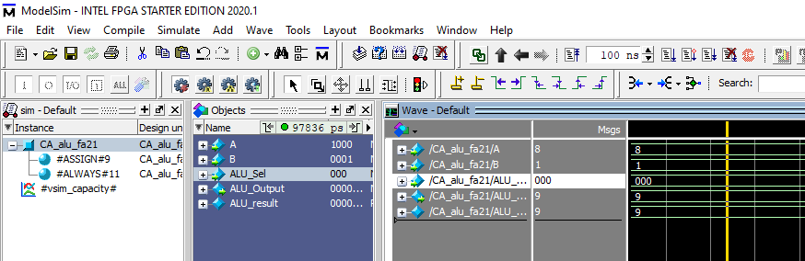

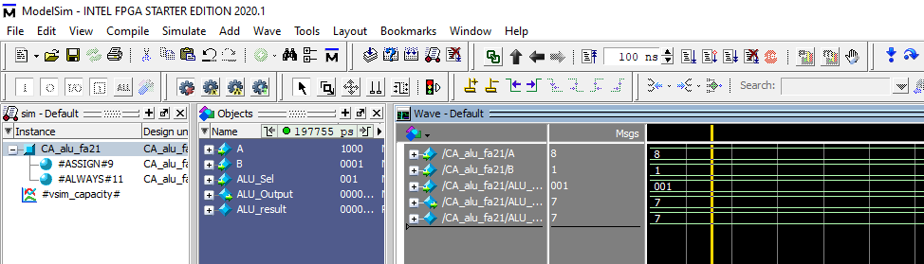

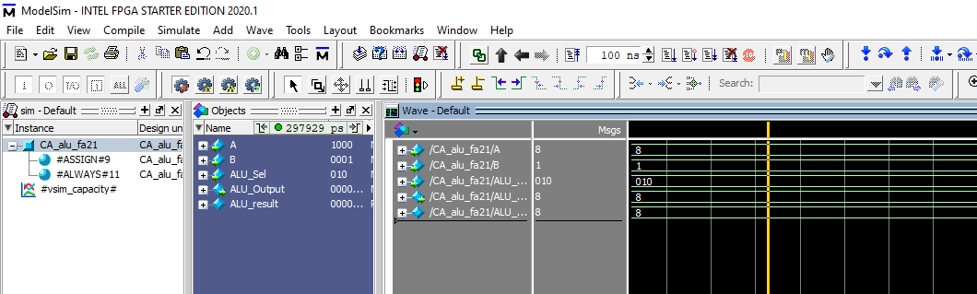

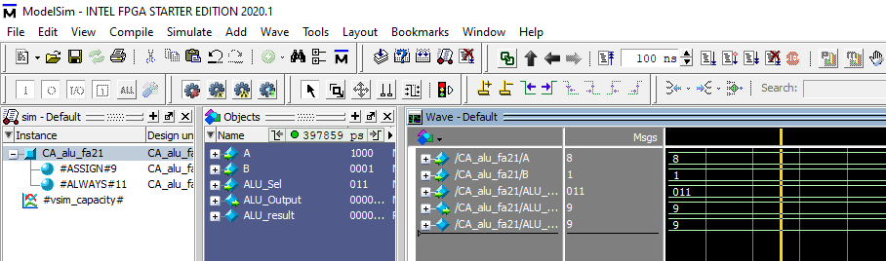

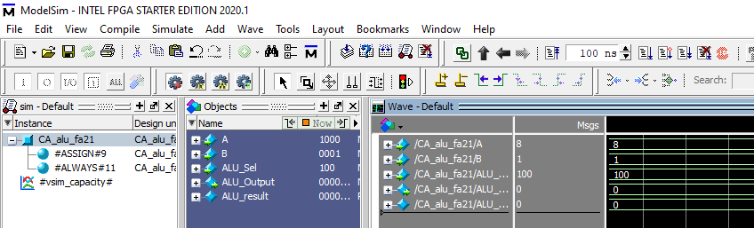

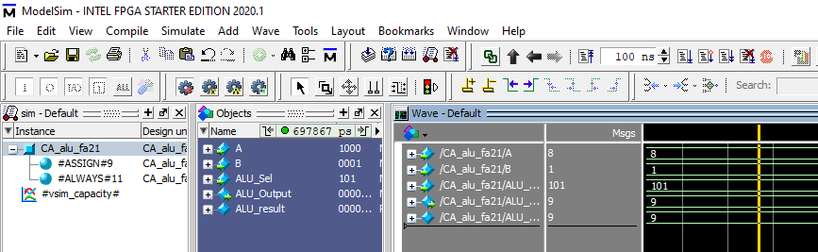

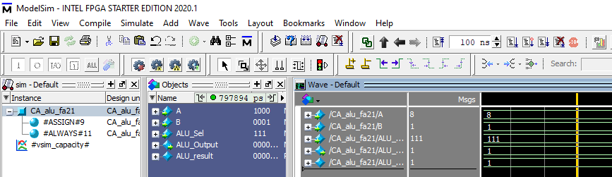

Conclusion and References

After defining the different cases using a switch statement the ALU was able to output each operation correctly.

